Sri Lanka Institute of Information

Technology

Lab Submission

<Lab sheet 10>

**<IT24102228>**

**<Welgama W. N. Y>**

**Probability and Statistics | IT2120**

B.Sc. (Hons) in Information Technology

**Exercise**



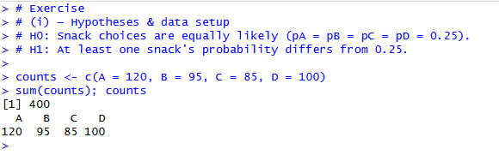



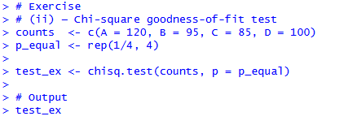

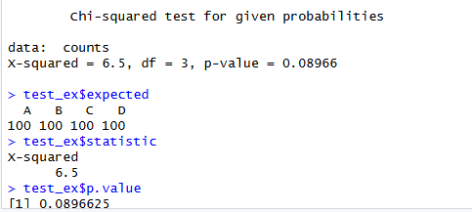

1. 